MQTT Configuration, Topics & Messages:
- Introduction:
The bi-directional communication between the data acquisition device and the database or WebApp strictly adheres to standard MQTT protocols. There is no direct connection between these devices; all data communication occurs through the MQTT broker, which distributes messages to all devices subscribed to a specific topic (see Fig.1).

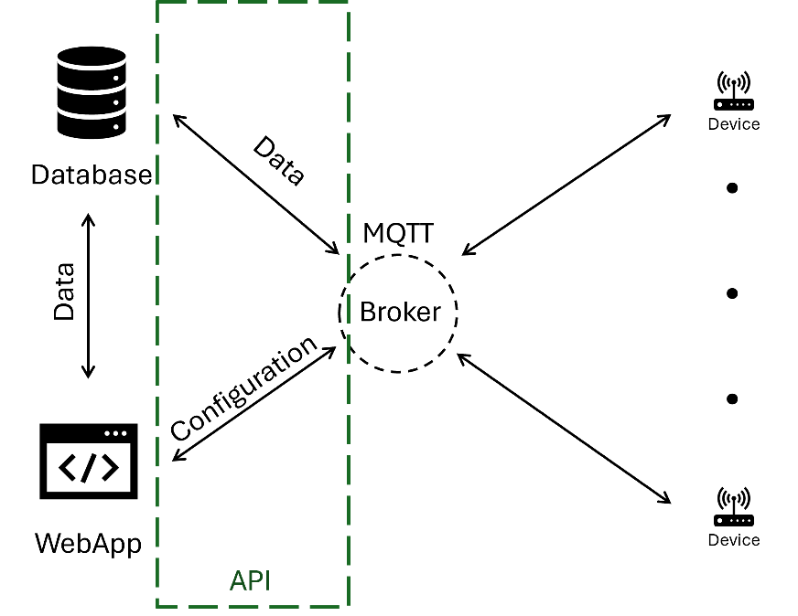
Figure 1. Communication and data transfer schematics
This document outlines the parameters for device configuration, relevant topics for retrieving and setting parameters/data, and the corresponding messages required for the data acquisition process.
- Versions and revision history

Version/Release number | Date | Description | Notes
MQQT Protocol V1.0.0 | 19/12/2024 | Draft | -
MQQT Protocol V1.0.1 | 19/12/2024 | QoS and Retain Update | -
MQQT Protocol V1.0.2 | 19/12/2024 | Transmission and JSON format | -
MQQT Protocol V1.0.3 | 20/12/2024 | Timestamp data adjustment | -
MQQT Protocol V1.0.4 | 20/12/2024 | Change “long” to “lng” for longitude | -
MQQT Protocol V1.0.5 | 20/12/2024 | Change Hard Reset topic | -
MQQT Protocol V1.0.6 | 27/12/2024 | Change “input” for AI , DI , DO | -
MQQT Protocol V1.0.7 | 08/01/2024 | passive , check ,miss update | -
MQQT Protocol V1.0.8 | 14/01/2024 | input | -
MQQT Protocol V1.0.9 | 16/01/2024 | heartbeats | -
MQQT Protocol V1.0.10 | 20/01/2025 | ack / seq | -
MQQT Protocol V1.0.11 | 06/02/2025 | analog update | -
MQQT Protocol V1.0.12 | 24/02/2025 | Digital Output | -
MQQT Protocol V1.0.13 | 28/02/2025 | Change IMEI to UDI | -
MQQT Protocol V1.0.14 | 12/03/2025 | Figures, Adjust timeStamps | -
MQQT Protocol V1.0.15 | 11/05/2026 | Optimisation, Document formatting, timestamp to Unix (32%), main sensor setup moved to AIs and referenced as AI0, versions moved to setup, including communication parameters, Correcting subtopic names and format, add Update rate | -

- General notations:
Each device has its own unique identifier that allows its distinction and serves as an address when the data is transferred through the broker. This unique identifier 16 digits representation of the device and a check digit (e.g., 202412141110000) and it is referred to as UDI. The UDI is stored inside the NFC Tag for recognition and/or QR code. It is also included in the device documentation. This identifier remains unchangeable/unchanged as long as the device is in operation.
The same topic is used for both getting and setting any parameters within the same mode.
Every message received from the device contains an acknowledgement to verify the reception and the validation of the request.
- Data Transmission
The data is transmitted without being requested. The device publishes the measured data to the broker.
  - Device to WebApp/Server:
Designation | Description | Format and values
trans | Data transmission topic
mode | Mode of the measurement | transientCap: Transient Capturing Mode,  passive: Passive testing Mode,  active: Active testing Mode,  monitor: Monitoring Mode
source | Source of measurement | AIi (Analog Input – in this case, additional parameters should be added - see Sec 9)  DIi (Digital Input – in this case, additional parameters should be added - see Sec 10)  Acc (Accelerometer - in this case, additional parameters should be added - see Sec 12)
meas | The measured data | Array
heartbeats | Heartbeats of the measured data | Array
freq | Measurement frequency | Usually 1kHz (left blank in case of monitoring)
startTime | Measurement Starting time | Time stamp in Unix format in milliseconds (Integer format)
seq | Sequence number | Positive Integer

Topic | Message (Json/String) | QoS | Retain
Device/UDI/trans | {  "mode":"monitor",  "data":[  {  "source":"AI0",  "meas":  [  14.025  ],  "heartbeats":  [  0  ],  "startTime":1733788800  }  ],  "freq":null,  "seq":123  } | 1 | True
Device/UDI/trans | {  "mode":"monitor",  "data":[  {  "source":"AI0",  "meas":  [  14.025  ],  "heartbeats":  [  0  ],  "startTime":1733788800  },  {  "source":"AI1",  "meas":  [  10.215  ],  "heartbeats":  [  0  ],  "startTime":1733788800  }  ],  "freq":null,  "seq":123  } | 1 | True
Device/UDI/trans | {  "mode":"passive",  "data":[  {  "source":"AI0",  "meas":  [  14.025,  14.025,  14.025  ],  "heartbeats":  [  0,  30,  100  ],  "startTime":1733788800  }  ],  "freq":null,  "seq":123  } | 1 | True
Device/UDI/trans | {  "mode":"transientCap",  "data":[  {  "source":"AI0",  "meas":[14.025, 14.025, 14.025],  "heartbeats":[0, 2000000, 3000000],  "startTime":1733788800  }  ],  "freq":null,  "seq":123  } | 1 | True
Note: Data for each mode is sent separately, even if two modes are active simultaneously.
  - Webapp/Server to Device
Designation | Description | Format and values
trans | Data transmission topic
mode | Mode of the measurement | transientCap: Transient Capturing Mode,  passive: Passive testing Mode,  active: Active testing Mode,  monitor: Monitoring Mode
ack | acknowledgement number | Negative Integer equals to seq(Error in receiving, parsing or applying);  Positive Integer equals to seq (Changes applied)

Topic | Message (Json/String) | QoS | Retain
Client/UDI/trans | {  "mode":"passive",  "ack":123  } | 1 | True
Note: The device retains the data within its memory until it receives an acknowledgment to prevent any data loss during transmission.
- Setup mode:
The parameters involved in this step are:
Designation | Description | Format and values
setup | Setup topic | 0 (First Time Activation),  1 (Get Parameter),  2 (Set Parameter),  3 (Reset)
seq | Sequence number | Positive Integer
ack | acknowledge number | Negative Integer equals to seq (Error in receiving, parsing or applying),  Positive Integer equals to seq (Changes applied)
UID | Device ID | 16-bit representation.
protocol* | Full communication topic | Array of data for MQTT configuration (protocol, host, user name, password, port, client ID, publish topic, subscribe topic)
con* | Connectivity Topic | Array of data for SIM Connectivity
fdd* | First Deployment Date | Unix Date format in seconds
reset | The type of the reset | H (Hardware reset),  S (Software reset)
ver* | Device version | Array that contains the firmware and hardware version
Note: Possible “getInf” are marked with ‘*’.
Designation | Description | Format and values
Protocol# | Full communication topic | Array of data communication configuration (protocol, host, username, password, port, client ID, publish topic, subscribe topic).
name# | Communication protocol | Name of the protocol: mqtt
host# | Host | The address of the host, e.g., "broker.emqx.io" for MQTT
username# | Username | String for secured access to the broker
pass# | Password | String for secured access to the broker
port# | Port | Port number: 1883 – Standard unencrypted MQTT over TCP, 8883 – MQTT over SSL/TLS for secure encrypted communication.
client# | Client ID | String (this is used to verify the connection to the broker)
pubTopic# | Publish Topic | String
subTopic# | Subscribe Topic | String
Note: Modifiable parameters are marked with ‘#’.
Note: All parameters are retrievable through “getInf”.
Designation | Description | Format and values
con | Full communication topic | Array of data communication configuration (protocol, host, username, password, port, client ID, publish topic, subscribe topic).
sim | ISMI (International mobile subscriber identity): Unique cellular network user identification | 15-digit number (3 digits for country code, 3 digits for network code and the rest for the actual sim card subscription identification number)
ip | Device IP address (dynamic) | Dotted decimal notation (String)
mac | Device Static MAC address (Fixed) | Six groups of two hexadecimal digits (String)
apnaddr# | APN Address | String
apnuser# | APN User | String
apnpass# | APN Pass | String
Note: Modifiable parameters are marked with ‘#’.
Note: All parameters are retrievable through “getInf”.
Note: the current version supports only the MQTT socket (over TCP or over TLS).
Designation | Description | Format and values
ver | Device version | Full topic that contains the firmware and hardware version
firm | Device Firmware version | e.g., 1.0.1
hard | Device Hardware version | e.g., 1.0
Note: All parameters are retrievable through “getInf”.
  - First-time setup:
The first-time setup is required to add a new device to the network. The same can be used to add used device once again. This means that the first-time setup is also a resetting option for the device with the maintain of the first deployment date.
    - WebApp/Server to Device:
The WebApp/Server sends a request to add a device and reset it as newly added device.
Topic | Message (Json/String) | QoS | Retain
Client/UDI/setup | {  "setup":0,  "seq":1  } | 2 | False

    - Device to WebApp/Server:
After receiving the activation and setting up request, the device answers by publishing an acknowledgement of the receipt of the message and its activation (Device online) including the device current configuration (default).
Topic | Message (Json/String) | QoS | Retain
Device/UDI/setup | {  "setup":0,  "ack":1,  "UDI":202412141110000,  "protocol":  {  "pr": "mqtt",  "host": "broker.emqx.io",  "port": 1883,  "username": "admin",  "pass": "password",  "client": "emqx-mqtt-user123",  "pubTopic": "Device/202412141110000I", "subTopic": "Client/202412141110000/"  },  "con":  {  "sim": "310260123456789",  "ip": "10.45.22.114",  "mac": "AA:BB:CC:DD:EE:FF", "apnaddr": "iot.telekom.com",  "apnuser": "m2m",  "apnpass": "m2mpass"  },  "fdd": 1715335200,  "ver":  {  "firm":"1.0.1",  "hard":"1.0"  }  } | 2 | False

  - Getting a single or multiple parameters
    - WebApp/Server to the device:
The WebApp/Server sends a request to retrieve information and its corresponding value from the device
Topic | Message (Json/String) | QoS | Retain
Client/UDI/setup | {  "setup":1,  "getInf":"all",  "seq":1  } | 2 | False
Client/UDI/setup | {  "setup":1,  "getInf":"ip",  "seq":1  } | 2 | False
Client/UDI/check | {  "check":1,  "getInf":"ver",  "seq":1  } | 2 | False
Client/UDI/check | {  "check":1,  "getInf":"protocol",  "seq":1  } | 2 | False

    - Device to WebApp/Server:
After receiving the get request, the device answers by publishing an acknowledgement of the receipt of the message and the value of the requested parameters.
Topic | Message (Json/String) | QoS | Retain
Device/UDI/setup | {  "setup":1,  "ack":1,  "UDI":202412141110000,  "protocol":  {  "pr": "mqtt",  "host": "broker.emqx.io",  "port": 1883,  "username": "admin",  "pass": "password",  "client": "emqx-mqtt-user123", "pubTopic": "Device/202412141110000I",  "subTopic": "Client/202412141110000/"  },  "con":  {  "sim": "310260123456789",  "ip": "10.45.22.114",  "mac": "AA:BB:CC:DD:EE:FF",  "apnaddr": "iot.telecom.com",  "apnuser": "m2m",  "apnpass": "m2mpass"  },  "fdd": 1715335200,  "ver":  {  "firm":"1.0.1",  "hard":"1.0"  }  } | 2 | False
Device/UDI/setup | {  "setup":1,  "ack":1,  "ip":"10.45.22.114"  } | 2 | False
Device/UDI/setup | {  "setup":1,  "ack":1,  "firm":"1.0.1",  "hard":"1.0"  } | 2 | False
Device/UDI/setup | {  "setup":1,  "ack":1,  "pr": "mqtt",  "host": "broker.emqx.io",  "port": 1883,  "username": "admin",  "pass": "password",  "client": "emqx-mqtt-user123",  "pubTopic": "Device/202412141110000I",  "subTopic": "Client/202412141110000/"  } | 2 | False

  - Change of a certain or multiple parameters:
    - WebApp/Server to the device:
The WebApp/Server sends a request to set/change a certain parameter (e.g., MQTT host address, user name or password) to the device
Topic | Message (Json/String) | QoS | Retain
Client/UDI/setup | {  "setup":2,  "user":"hyeleUser",  "pass":"hyele@2026",  "seq":1  } | 2 | False

    - Device to WebApp/Server:
After receiving the set message, the device answers by publishing an acknowledgement of the message's receipt and the change of the requested parameter.
Topic | Message (Json/String) | QoS | Retain
Device/UDI/setup | {  "setup":2,  "ack":1,  "user":"hyeleUser",  "pass":"hyele@2026"  } | 2 | False
Note: if the value cannot be changed manually (e.g., a MAC or IP address), the device sends the same response with the correct (unchanged) parameter values.
  - Resetting:
    - WebApp/Server to the device:
The WebApp/Server sends a request for the device software reset (return values to default).
Topic | Message (Json/String) | QoS | Retain
Client/UDI/setup | {  "setup":3,  "seq":1  } | 2 | False
No request (Hard reset)
Note: In case of a hardware reset, the device should answer to this request even without being requested.
    - Device to WebApp/Server:
After receiving a software reset request, the device resets and sends an acknowledgement along with the parameters it has. It also can send an answer without being requested in case of a hardware reset.
Topic | Message (Json/String) | QoS | Retain
Device/UDI/setup | {  "setup":3,  "ack":1,  "reset":"S"  } | 2 | False
Device/UDI/setup | {  "setup":3,  "seq":1,  "reset":"H"  } | 2 | False
After WebApp/Server receives a Hard reset message, the server side responds with an acknowledgement
Client/UDI/reset | {  "setup":3,  "ack":1, "  reset":"H"  } | 2 | False
Note: Resetting a device does not change the first deployment date, as it is a quantification for the device's life cycle.
- Check mode:
The check mode requests the device to provide its status, including the GPS status (fix), 4G RSSI level (ranging from 1 to 4), internet connectivity, and remaining battery life. It also includes the device's location in the form of geographical coordinates.
Designation | Description | Format and values
check | Check topic | 0 (Automatic update),  1 (requested update)
rep | Automated check interval | Time in seconds (required for automatic check only) (0 for deactivated)
loc | Request for Location/ Coordinates | time, latitude and longitude: time, lat, lng
gps | GPS status (Has a fix) | 0 (No fix),  1 (Fix, Synchronisation active)
rssi | 4G RSSI (Signal Strength) | 1 to 4
isi | Internet Strength Indicator | 0 – 4 (0-1 for extremely slow, 2 for 2G, 3 for 3G and 4 for 4G)
pwr | Battery remaining power | 0 to 100 (Charging rate: 0 – 100%)
chg | Battery charging – an indicator of the solar panels being activated or not. | 1 (Battery charging),  0 (No charging)
remData | Remaining Data in the SIM Card | A number in Mb (1024 Mb remaining as 1Gb remaining as data on the SIM card)
lastCon | Last time connected: Last attempt to send data due to connection problems. | Time Stamp in Unix
Note: All parameters are retrievable through “getInf”.

Designation | Description | Format and values
conn | Connectivity parameters check | Contains the parameters of the GPS (gps), 4G connection (rssi), and internet strength (isi)
loc | Request for Location/ Coordinates | time, latitude and longitude: time, lat, lng
Note: All parameters are retrievable through “getInf”.
  - WebApp/Server to the device:
The WebApp/Server sends a request to check the device current status.
Topic | Message (Json/String) | QoS | Retain
Client/UDI/check | {  "check":1,  "getInf":"loc",  "seq":1  } | 2 | False
Client/UDI/check | {  "check":1,  "getInf":"conn",  "seq":1  } | 2 | False
Client/UDI/check | {  "check":1,  "getInf":"all",  "seq":1  } | 2 | False
Client/UDI/check | {  "check":0,  "rep":30,  "getInf":"conn",  "seq":1  } | 2 | False

  - Device to WebApp/Server:
After receiving a check request, the device returns an acknowledgement and a list of the requested parameters. Note that the check can either get all the information, the location information or just the connectivity and battery information.
Topic | Message (Json/String) | QoS | Retain
Device/UDI/check | {  "check":1,  "ack":1,  "lat":"1.123,N",  "lng":"1.123, E",  "time":1737763200  } | 2 | False
Device/UDI/check | {  "check":1,  "ack":1,  "gps":1,  "rssi":2,  "isi":1  } | 2 | False
Device/UDI/check | {  "check":1,  "ack":1,  "rep":0,  "lat":"1.123,N",  "lng":"1.123,E",  "time":1737763200,  "gps":1,  "rssi":2,  "isi":1,  "pwr":50,  "chg":0,  "remData":2048,  "lastCon":1737763200  } | 2 | False
Device/UDI/check | {  "check":0,  "ack":1,  "rep":30,  "gps":1,  "rssi":2,  "isi":1  }# | 2 | False
Note: # Topic published automatically every rep seconds.
- Monitoring mode:
Monitoring mode is the mode where the device listens to a certain measured quantity and sends the data at a very low frequency (1 sample per minute to 1 sample per hour).
Designation | Description | Format and values
monitor | Monitoring topic | 1 (Get Parameter),  2 (Set Parameter),
input | Input to monitor | AIi (Analog Input – in this case, additional parameters should be added - see Sec 9)  DIi (Digital Input – in this case, additional parameters should be added - see Sec 10)  Acc, AccX, AccY, AccZ (Accelerometer - in this case, additional parameters should be added - see Sec 12)
act | Activation | 0 (Disactivate),  1 (Activate),  -1 (Error in setup)
startTime | Start monitoring time | Time Stamp (0 in case of start-now)
inter | Time interval between measurements | In minutes (one to 60)
Note: All parameters are retrievable through “getInf”.
  - Set monitoring parameters:
    - WebApp/Server to the device:
The WebApp/Server sends a request to activate monitoring at certain inputs. Note that additional information is required if the input is not the main sensor (see sections 9,10 and 12).
Topic | Message (Json/String) | QoS | Retain
Client/UDI/monitor | {  "monitor":2,  "act":1,  "input":"AI0",  "startTime":1737723000,  "inter":10,  "seq":1  } ^{#1} | 2 | False
Client/UDI/monitor | {  "monitor":2,  "act":1,  "input":"AI1",  "startTime":0,  "seq":1  } | 2 | False
Client/UDI/monitor | {  "monitor":2,  "act":1,  "input":"Acc",  "startTime":0,  "inter":10,  "seq":1  } ^{#2} | 2 | False
Note: The lack of information results in a false acknowledgement. This means that if the request contains less data than required to activate the monitoring process, the device sends a false acknowledgement.
Note: (#1) refers to activating monitoring on AI0 with a 10-second time interval and at the second Unix time stamp 1737723000
(#2) refers to activating instantaneous monitoring on the accelerometer (all three axes) with a 10-second time interval
    - Device to WebApp/Server:
After receiving a set monitoring request, the device returns an acknowledgement and a request to complete any missing data (refer to the above-mentioned sections).
Topic | Message (Json/String) | QoS | Retain
Device/UDI/monitor | {  "monitor":2,  "ack":1,  "act":1,  "input":"AI0"  } | 2 | False
Device/UDI/monitor | {  "monitor":2,  "ack":-1,  "act":0,  "input":"AI1"  } | 2 | False
Device/UDI/monitor | {  "monitor":2,  "ack":1,  "act":1,  "input":"Acc"  } | 2 | False

  - Get monitoring parameters:
    - WebApp/Server to the device:
The WebApp/Server sends a request to get the monitoring information.
Topic | Message (Json/String) | QoS | Retain
Client/UDI/monitor | {  "monitor":1,  "getInf":"all",  "input":"AI0",  "seq":1  } | 2 | False
Client/UDI/monitor | {  "monitor":1,  "getInf":"act",  "input":"AI1",  "seq":1  } | 2 | False

    - Device to WebApp/Server:
After receiving a monitoring get-configuration request, the device returns an acknowledgement and the requested information.
Topic | Message (Json/String) | QoS | Retain
Device/UDI/monitor | {  "monitor":1,  "ack":1,  "act":1,  "input":"AI0",  "startTime":1737723000,  "inter":10  } | 2 | False
Device/UDI/monitor | {  "monitor":1,  "ack":1,  "act":1,  "input":"AI1"  } | 2 | False

- Transient capturing Mode:
When the device operates in transient capturing mode, it continuously collects pressure data from a sensor at a high frequency. During this time, it stores the pressure readings and calculates the average, referred to as a data chunk. Each chunk contains a certain number of measurements (e.g., for a frequency of 1kHz and a time length of the sample is 1 second, the size of the sample is 1000 measurements). This process is repeated to create multiple chunks, typically three (herein referred to as the number of samples). The device then compares these average values; if they are similar, it discards the oldest chunk and collects a new one, maintaining only the most recent three (see Fig. 2). The device evaluates average pressure against a predefined threshold. If significant differences are detected among the averages, it indicates a potential pressure surge. Upon detecting a surge, it triggers an alert, sending the last three data chunks to a web application and new data collected after the surge for a user-defined period.

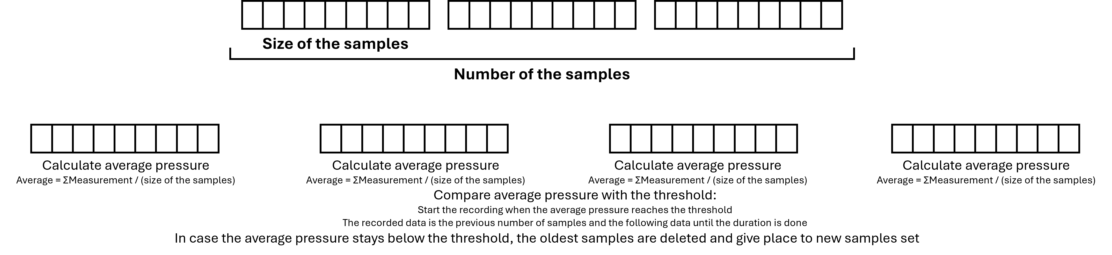
Figure 2. Transient capturing mechanism schematics
Designation | Description | Format and values
transientCap | Transient capturing Topic | 1 (Get Parameter),  2 (Set Parameter),
input | Input to monitor for transient capturing | AIi (Analog Input – in this case, additional parameters should be added - see Sec 9)  DIi (Digital Input – in this case, additional parameters should be added - see Sec 10)  Acc (Accelerometer - in this case, additional parameters should be added - see Sec 12)
act* | Activation | 0 (Disactivate),  1 (Activate)
nbrChunk* | Number of samples | An integer number (Usually around three)
sizeChunk* | Chunk size (Number of measurements in a single chunk) | Usually around one second of measurement
freq* | Sampling frequency | Integer: usually around 1000:1kHz
dur* | The transient measurement duration | Advised to be less than the minutes (Large durations may induce larger power consumption)
thd* | A threshold pressure, a pressure elevation higher or lower than the threshold, is considered a transient event (Threshold can be multiple values) | An array of values: A certain value of pressure (Strictly positive and should be higher or lower than the system pressure)
Note: Possible “getInf” are marked with ‘*’.
  - Set transient capturing parameters:
    - WebApp/Server to the device:
The WebApp/Server sends a request to activate transient capturing at certain inputs. Additional information is required if the input is not the main sensor (see sections 9,10 and 12).
Topic | Message (Json/String) | QoS | Retain
Client/UDI/transientCap | {  "transientCap":2,  "act":1,  "input":"AI0",  "nbrChunk":3,  "sizeChunk":1000,  "freq":1000,  "dur": 10,  "thd":  [  2,  10  ],  "seq":1  } | 2 | False
Client/UDI/transientCap | {  "transientCap":2,  "act":1,  "input":"AI1",  "nbrChunk":3,  "sizeChunk":1000,  "freq":1000,  "dur": 10,  "threshold":  [  4  ],  "seq":1  } | 2 | False
Note: The lack of information results in a false acknowledgement. This means that if the request contains less data than required to activate the transient capturing process, the device sends a false to the acknowledgement. In other words, for example, if an Analog input is not set, it cannot be used.
    - Device to WebApp/Server:
After receiving a set transient capturing request, the device returns an acknowledgement and a request to complete any missing data (refer to the above-mentioned sections).
Topic | Message (Json/String) | QoS | Retain
Device/UDI/transientCap | {  "transientCap":2,  "ack":1,  "act":1,  "input":"AI0"  } | 2 | False
Device/UDI/transientCap | {  "transientCap":2,  "ack":-1,  "act":0,  "input":"AI1"  } | 2 | False

  - Get transient capturing parameters:
    - WebApp/Server to the device:
The WebApp/Server sends a request to get the transient capturing configuration.
Topic | Message (Json/String) | QoS | Retain
Client/UDI/transientCap | {  "transientCap":1,  "getInf":"all",  "input":"AI0",  "seq":1  } | 2 | False
Client/UDI/transientCap | {  "transientCap":1,  "getInf":"freq",  "input":"AI0",  "seq":1  } | 2 | False

    - Device to WebApp/Server:
After receiving a transient capturing get-configuration request, the device returns an acknowledgement and the requested information.
Topic | Message (Json/String) | QoS | Retain
Device/UDI/transientCap | {  "transientCap":1,  "ack":1,  "input":"AI0",  "nbrChunk":3,  "sizeChunk":1000,  "freq":1000,  "threshold":  [  2,  10  ]  } | 2 | False
Device/UDI/transientCap | {  "transientCap":1,  "ack":1,  "freq":1000,  "input":"AI0"  } | 2 | False

- Passive testing mode:
Passive testing involves the device listening to and measuring pressure, as well as data from other Analog and Digital inputs or the embedded accelerometers without actively altering the environment. During this mode, the device continuously monitors these inputs for changes. At a predetermined time, it begins measuring, saving and forwarding the data for a predefined duration.
Designation | Description | Format and values
passive | Passive Testing Topic | 1 (Get Parameter),  2 (Set Parameter),
input | Input to monitor for transient capturing | Main (set to main sensor by default),  AIi (Analog Input – in this case, additional parameters should be added - see Sec 9)  DIi (Digital Input – in this case, additional parameters should be added - see Sec 10)  Acc (Accelerometer - in this case, additional parameters should be added - see Sec 12)
act* | Activation | 0 (Disactivate),  1 (Activate)
uprate* | Update rate | Update Rate in seconds (Available for all modes except monitoring)
startTime* | Start measuring time in seconds | A Time Stamp,  The value can be 0 (as start now)
freq* | Sampling frequency | Around 1kHz
dur* | The transient measurement duration | Advised to be less than the minutes (Large durations may induce larger power consumption)
Note: In cases of repetitive measurements, each device is designed to handle multiple requests, storing them in memory until the designated tests are completed within a 25-hour window. Repetitive measurements refer to situations where multiple tests occur within a single day or when measurements are needed from various analogue inputs, digital inputs, or accelerometers. It is the responsibility of the WebApp or server to monitor scheduled tests and dispatch requests accordingly.
Note: Possible “getInf” are marked with ‘*’.
  - Set passive testing parameters:
    - WebApp/Server to the device:
The WebApp/Server sends a request to activate passive testing at certain inputs. Additional information is required if the input is not the main sensor (see sections 9,10 and 12).
Topic | Message (Json/String) | QoS | Retain
Client/UDI/passive | {  "passive":2,  "act":1,  "input":"AI0",  "uprate":10,  "startTime":1736936100,  "freq":1000,  "dur":300,  "seq":1  } | 2 | False
Client/UDI/passive | {  "passive":2,  "act":1,  "input":"AI1",  "uprate":10,  "startTime":1736936100,  "freq":1000,  "dur":200,  "seq":1  } | 2 | False
Note: The lack of information results in a false acknowledgement. This means that if the request contains less data than required to activate the passive testing process, the device sends a false to the acknowledgement. In other words, for example, if an Analog input is not set, it cannot be used.
    - Device to WebApp/Server:
After receiving a passive test request, the device returns an acknowledgement and a request to complete any missing data (refer to the above-mentioned sections).
Topic | Message (Json/String) | QoS | Retain
Device/UDI/passive | {  "passive":2,  "ack":1,  "act":1,  "input":"AI0"  } | 2 | False
Device/UDI/passive | {  "passive":2,  "ack":-1,  "act":0,  "input":"AI1"  } | 2 | False

  - Get passive testing parameters:
    - WebApp/Server to the device:
The WebApp/Server sends a request to get the passive configuration.
Topic | Message (Json/String) | QoS | Retain
Client/UDI/passive | {  "passive":1,  "getInf":"all",  "input":"AI0",  "seq":1  } | 2 | False
Client/UDI/passive | {  "passive":1,  "getInf":"startTime",  "input":"AI0",  "seq":1  } | 2 | False

    - Device to WebApp/Server:
After receiving a passive test get-configuration request, the device returns an acknowledgement and the requested information.
Topic | Message (Json/String) | QoS | Retain
Device/UDI/passive | {  "passive":1,  "ack":1,  "act":1,  "input":"AI0",  "uprate":10,  "startTime":  [  1736936100  ],  "freq":  [  1000  ],  "dur":  [  300  ]  } | 2 | False
Device/UDI/passive | {  "passive":1,  "ack":1,  "input":"AI0",  "startTime":  [  1736936100,  1736938100  ]  } | 2 | False

- Active testing mode:
Active testing is similar to passive testing, with the key addition of activating a digital output, which serves as a source of transient signals. In this mode, the device not only listens to and measures pressure and other inputs, such as from Analog and digital sensors or accelerometers but also initiates a controlled output. This activation generates specific transient conditions that can be monitored and analysed. The device continuously records the resulting measurements during this process, capturing both the baseline data and the effects of the activated digital output.
Designation | Description | Format and values
active | Active Testing Topic | 1 (Get Parameter),  2 (Set Parameter),
input | Input to monitor for transient capturing | Main (set to main sensor by default),  AIi (Analog Input – in this case, additional parameters should be added - see Sec 9)  DIi (Digital Input – in this case, additional parameters should be added - see Sec 10)  Acc (Accelerometer - in this case, additional parameters should be added - see Sec 12)
act | Activation | 0 (Disactivate),  1 (Activate)
uprate* | Update rate | Update Rate in seconds (Available for all modes except monitoring)
startTime* | Start measuring time in seconds | A Time Stamp,  The value can be 0 (as start now)
freq* | Sampling frequency | Around 1kHz
dur* | The transient measurement duration | Advised to be less than the minutes (Large durations may induce larger power consumption)
timeOut* | Period of time to capture baseline data:  Delay in operating the DO | Time in seconds (can be 0), but strictly less than the duration. (It can be an array in case of multiple activations)
output* | DO of control | DO1 or DO2 (it can be an array in case of multiple activations)
Note: The input control is the WebApp/server to duty. The device will shift from its current status at timeOut and shift back again at dur (both measured from startTime).
Note: Possible “getInf” are marked with ‘*’.
  - Set active testing parameters:
    - WebApp/Server to the device:
The WebApp/Server sends a request to activate active testing at certain inputs. Additional information is required if the input is not the main sensor (see sections 9,10 and 12).
Topic | Message (Json/String) | QoS | Retain
Client/UDI/active | {  "active":2,  "act":1,  "input":"AI0",  "uprate":10,  "startTime":1736936100,  "freq":1000,  "dur":300,  "output":  [  "DO1",  "DO2"  ],  "timeout ":  [  50,  100  ],  "seq":1  } | 2 | False
Client/UDI/active | {  "active":2,  "act":1,  "input":"AI0",  "uprate":10,  "startTime":1736936100,  "freq":1000,  "dur":300,  "output":  [  "DO1",  "DO1",  "DO1"  ],  "timeout ":  [  50,  100,  200  ],  "seq":1  } | 2 | False
Note: The lack of information results in a false acknowledgement. This means that if the request contains less data than required to activate the passive testing process, the device sends a false to the acknowledgement. In other words, for example, if an Analog input is not set, it cannot be used.
Fig. 3 and Fig. 4 illustrate the two examples:
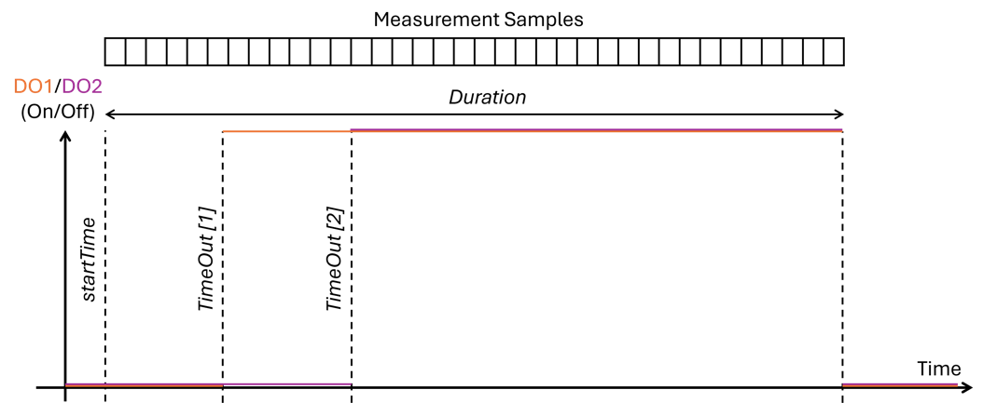
Figure 3. Variation of the Digital outputs based on the first request: DO1 is activated at timeOut[1] and DO2 is activated at timeOut[2] and both regain their initial state after the end of the test (duration)

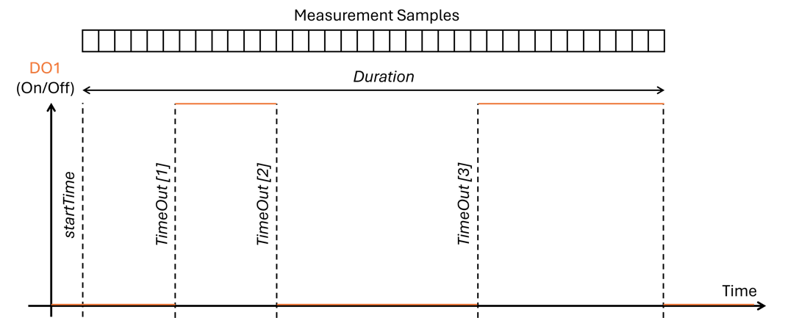
Figure 4. Variation of the Digital output DO1 based on the first request: DO1 is activated at timeOut[1], deactivated at timeOut[2] and reactivated once more at timeOut[3]. It regains its initial state after the end of the test (duration)

    - Device to WebApp/Server:
After receiving an active test request, the device returns an acknowledgement and a request to complete any missing data (refer to the above-mentioned sections).
Topic | Message (Json/String) | QoS | Retain
Device/UDI/active | {  "active":2,  "ack":1,  "input":"AI0",  "act":1  } | 2 | False
Device/UDI/active | {  "active":2,  "ack":1,  "input":"AI0",  "act":1  } | 2 | False

  - Get active testing parameters:
    - WebApp/Server to the device:
The WebApp/Server sends a request to get the active testing configuration.
Topic | Message (Json/String) | QoS | Retain
Client/UDI/active | {  "active":1,  "getInf":"all" ,  "input":"AI0" ,  "seq":1  } | 2 | False
Client/UDI/active | {  "active":1,  "getInf":"dur",  "input":"AI0",  "seq":1  } | 2 | False

    - Device to WebApp/Server:
After receiving an active test get-configuration request, the device returns an acknowledgement and the requested information.
Topic | Message (Json/String) | QoS | Retain
Device/UDI/active | {  "active":1,  "ack":1,  "act":1,  "input":"AI0",  "uprate":10,  "startTime":1736936100,  "freq":1000,  "duration":300,  "output":  [  "DO1",  "DO2"  ],  "timeout":  [  50,  100  ]  } | 2 | False
Device/UDI/active | {  "active":1,  "ack":1,  "input":"AI0",  "dur":300  } | 2 | False

- Analog input (AI) setup:
The device's Analog inputs (AI) support both current and voltage signals. Based on the type of the sensor connected to a certain input, the signal type (current or voltage), the full scale and the accuracy of the sensor along with the quantity being measured (flow, pressure, acceleration). Inputs are deactivated to be used in tests (monitoring, passive or active testing).
Designation | Description | Format and values
analog | Analog Input Topic | 1 (Get Parameter),  2 (Set Parameter),
input | Input to monitor for transient capturing | AIi (Analog Input number)
act* | Activation | 0 (Disactivate),  1 (Activate)
quant* | Physical quantity to measure | pr for pressure,  fl for flow,  ax for acceleration and vibrations
type* | Type of the signal | volt for voltage (up to 0 - 24V),  cur for current signals (4-20mA)
fS* | Full scale of the sensor connected to the Analog Input | It is set depending on the connected sensor.  Array: e.g., [16, 10] for a 16-bar full scale and a measurement range of (0-10V)
acc* | Sensor Accuracy | A ratio in %
unit* | Measurement unit | It is set depending on the connected sensor.
serial* | Connected Device Serial number | A set of numbers (usually around 8 to 10 digits)
depDate* | Deployment date of the sensor | Timestamp (Unix format)
Note: Possible “getInf” are marked with ‘*’.
  - Add Analog input:
    - WebApp/Server to the device:
The WebApp/Server sends a request to configure an Analog input and set its parameters
Topic | Message (Json/String) | QoS | Retain
Client/UDI/analog | {  "analog":2,  "input":"AI1" ,  "act":1,  "quant":"pr",  "type":"volt",  "fS":  [  10,  10  ],  "acc":0.5,  "unit":"bar",  "serial":"00112233",  "depDate":"1737763200",  "seq":1  } | 2 | False
Client/UDI/analog | {  "analog":2,  "input":"AI1" ,  "act":1,  "quant":"pr",  "type":"volt",  "fS":  [  10,  10  ],  "acc":0.5,  "unit":"bar",  "seq":1  } | 2 | False
Note: The above is an example of setting a pressure sensor that delivers 0-10V with a full scale of 10 bars and an accuracy of 0.5%. Its serial number is 0112233 and it was deployed on the 25th of January 2025, connected to the first Analog input (AI1).
Note: Serial is an optional parameter; if it is not included in the settings, it is added automatically as ‘000000’. This applies also to the depDate if it is empty, the device assigns the request date as a deployment date. The WebApp/Server is responsible for checking the rest of the information.
    - Device to WebApp/Server:
After receiving a request to add, the device returns an acknowledgement.
Topic | Message (Json/String) | QoS | Retain
Device/UDI/analog | {  "analog":2,  "ack":1,  "input": "AI1"  } | 2 | False
Device/UDI/analog | {  "analog":2,  "ack":1,  "input": "AI1"  } | 2 | False

  - Set Analog input parameters:
    - WebApp/Server to the device:
The WebApp/Server sends a request to change a single or multiple parameters of an Analog input.
Topic | Message (Json/String) | QoS | Retain
Client/UDI/analog | {  "analog":2,  "input": "AI1",  "fS":  [  10,  10  ],  "acc":0.5,  "seq":1  } | 2 | False
Client/UDI/analog | {  "analog":2,  "input":"AI2",  "unit":"l/s",  "seq":1  } | 2 | False

    - Device to WebApp/Server:
After receiving a request to change a parameter, the device returns an acknowledgement of the change.
Topic | Message (Json/String) | QoS | Retain
Device/UDI/analog | {  "analog":2,  "ack":1,  "input": "AI1"  } | 2 | False
Device/UDI/analog | {  "analog":2,  "ack":1,  "input": "AI2"  } | 2 | False

  - Get Analog input parameters:
    - WebApp/Server to the device:
The WebApp/Server sends a request to get an Analog input configuration.
Topic | Message (Json/String) | QoS | Retain
Client/UDI/analog | {  "analog":1,  "input":"AI1",  "getInf":"all",  "seq":1  } | 2 | False
Client/UDI/analog | {  "analog":1,  "input":"AI1",  "getInf":"fS",  "seq":1  } | 2 | False

    - Device to WebApp/Server:
After receiving a request to change a parameter, the device returns an acknowledgement and the requested parameters.
Topic | Message (Json/String) | QoS | Retain
Device/UDI/analog | {  "analog":1,  "acc":1,  "input":"AI1",  "act":0,  "quant":"pr",  "type":"volt",  "fS":  [  10,  10  ],  "acc":0.5,  "unit":"bar",  "serial":"00112233",  "depDate":"20250125",  "ack":1  } | 2 | False
Device/UDI/analog | {  "analog":1,  "acc":1,  "input":"AI1",  "fS":  [  10,  10  ],  "ack":1  } | 2 | False
Note: In case there are no parameters to retrieve, the device will reply with a false acknowledgement.
- Digital input (DI) setup:
Similarly to the Analog inputs, digital inputs should be configured before being used as measurement inputs. Inputs are deactivated to be used in tests (monitoring, passive or active testing).
Designation | Description | Format and values
digital | Digital Input Topic | 1 (Get Parameter),  2 (Set Parameter),
input | Input number | DIi (Digital Input)
act* | Activation | 0 (Disactivate),  1 (Activate)
type* | Type of connection | e.g. ‘val’ for Valve response measurement
serial* | Connected Device Serial number | A set of numbers (usually around 8 to 10 digits)
depDate* | Deployment date of the sensor | Timestamp (Unix format)
Note: Possible “getInf” are marked with ‘*’.
  - Add digital input:
    - WebApp/Server to the device:
The WebApp/Server sends a request to configure a digital input and set its parameters.
Topic | Message (Json/String) | QoS | Retain
Client/UDI/digital | {  "digital":2,  "input":"DI1",  "act":0,  "type":"val",  "serial":"00112233",  "depDate":"1736936100",  "seq":1  } | 2 | False
Note: Serial is an optional parameter in case it is not included in the setting parameters, it is added automatically as ‘000000’. This applies also to the depDate if it is empty, the device assigns the request date as a deployment date. It is up the WebApp/Server to check the rest of the information
    - Device to WebApp/Server:
After receiving a request to add, the device returns an acknowledgement.
Topic | Message (Json/String) | QoS | Retain
Device/UDI/digital | {  "digital":2,  "ack":1,  "input":"DI1"  } | 2 | False

  - Set digital input:
    - WebApp/Server to the device:
The WebApp/Server sends a request to change a single or multiple parameters of an Analog input.
Topic | Message (Json/String) | QoS | Retain
Client/UDI/digital | {  "digital":2,  "input":"DI1",  "serial":"00001111",  "seq":1  } | 2 | False

    - Device to WebApp/Server:
After receiving a request to change a parameter, the device returns an acknowledgement of the change.
Topic | Message (Json/String) | QoS | Retain
Device/UDI/digital | {  "digital":2,  "ack":1,  "seq":1  } | 2 | False

  - Get digital input parameters:
    - WebApp/Server to the device:
The WebApp/Server sends a request to get a single or multiple parameters of an digital input.
Topic | Message (Json/String) | QoS | Retain
Client/UDI/digital | {  "digital":1,  "input":"DI1",  "getInf":"all",  "seq":1  } | 2 | False
Client/UDI/digital | {  "digital":1,  "input":"DI1",  "getInf":"type",  "seq":1  } | 2 | False

    - Device to WebApp/Server:
After receiving a request to get a parameter, the device returns an acknowledgement and the requested information.
Topic | Message (Json/String) | QoS | Retain
Device/UDI/digital | {  "digital":1,  "acc":1,  "input": "DI1",  "type":"val",  "serial":"00112233",  "depDate":"20250125",  "ack":1  } | 2 | False
Device/UDI/digital | {  "digital":1,  "acc":1,  "input":"DI1",  "type":"val",  "ack":1  } | 2 | False

- Accelerometer setup:
The device has an embedded tri-axial accelerometer that is to be set by indicating its range and the activated axis.
Designation | Description | Format and values
accelerometer | Accelerometer Input Topic | 1 (Get Parameter),  2 (Set Parameter),
act* | Activation | 0 (Disactivate),  1 (Activate)
range* | The range of the accelerometer | An array of 2, 4 , 8, 16 (in g) as a range for each axis (e.g.,[2,2,2] )
axis* | Active Axis | An array of any combination of x, y, z (e.g., [x;y] for the activation of x and y axis)
Note: Possible “getInf” are marked with ‘*’.
  - Set accelerometer:
    - WebApp/Server to the device:
The WebApp/Server sends a request to set the accelerometer parameters.
Topic | Message (Json/String) | QoS | Retain
Client/UDI/accelerometer | {  "accelerometer":2,  "act":0,  "range":  [  2,  2,  2  ],  "axis":  [  "x",  "y",  "z"  ],  "seq":1  } | 2 | False

    - Device to WebApp/Server:
The device responds by publishing an acknowledgement when the parameters are set correctly.
Topic | Message (Json/String) | QoS | Retain
Device/UDI/accelerometer | {  "accelerometer":2,  "ack":1  } | 2 | False

  - Get accelerometer parameters:
    - WebApp/Server to the device:
The WebApp/Server sends a request to get the accelerometer parameters.
Topic | Message (Json/String) | QoS | Retain
Client/UDI/accelerometer | {  "accelerometer":1,  "getInf":"all",  "seq":1  } | 2 | False
Client/UDI/accelerometer | {  "accelerometer":1,  "getInf":"axis",  "seq":1  } | 2 | False

    - Device to WebApp/Server:
After receiving a request to get a parameter, the device returns an acknowledgement and the requested information.
Topic | Message (Json/String) | QoS | Retain
Device/UDI/accelerometer | {  "accelerometer":1,  "ack":1,  "act":0,  "range":  [  2,  2,  2  ],  "axis":  [  "x",  "y",  "z"  ]  } | 2 | False
Device/UDI/accelerometer | {  "accelerometer":1,  "ack":1,  "axis":  [  "x",  "y",  "z"  ]  } | 2 | False

- Digital output (DO) setup:
Setting up digital output is allocating that output to a certain device or/and setting a pattern.
Designation | Description | Format and values
digitalOut | Digital output Topic | 1 (Get Parameter),  2 (Set Parameter),
output | output number | DOi (Digital output)
act* | Activation | 0 (Disactivate),  1 (Activate)
type* | Type of connection | e.g. ‘val’ for Valve response measurement
startTime* | The activation time in seconds | A Time Stamp (Unix format),  The value can be 0 (as start now)
pattrTime | Pattern Time vector | Time Pattern ; Positive Integer
pattrVal | Pattern Values vector | Pattern vector; {0,1}
Pattr* | Pattern Matrix | The pattern vectors (pattrTime, pattrVal)
Note: pattrTime and pattrVal are vectors of the same size.
Note: Possible “getInf” are marked with ‘*’.
  - Set digital output:
    - WebApp/Server to the device:
The WebApp/Server sends a request to set the digital output parameters.
Topic | Message (Json/String) | QoS | Retain
Client/UDI/digitalOut | {  "digitalOut":2,  "output":"DO1",  "act":0,  "type":"val",  "pattrTime":  [  0,  100,  300  ],  "pattrVal":  [  0,  1,  0  ],  "seq":1,  "startTime":1736936100  } | 2 | False

    - Device to WebApp/Server:
The device responds by publishing an acknowledgement when the parameters are set correctly.
Topic | Message (Json/String) | QoS | Retain
Device/UDI/digitalOut | {  "digitalOut":2,  "ack":1  } | 2 | False

  - Get digital output parameters:
    - WebApp/Server to the device:
The WebApp/Server sends a request to get the output parameters.
Topic | Message (Json/String) | QoS | Retain
Client/UDI/digitalOut | {  "digitalOut":1,  "output":"DO1",  "getInf":"all",  "seq":1  } | 2 | False
Client/UDI/digitalOut | {  "digitalOut":1,  "output":"DO1",  "getInf":"pattr",  "seq":1  } | 2 | False

    - Device to WebApp/Server:
After receiving a request to get a parameter, the device returns an acknowledgement and the requested information.
Topic | Message (Json/String) | QoS | Retain
Device/UDI/digitalOut | {  "digitalOut":1,  "ack":1,  "output":"DO1",  "act":0,  "type":"val",  "pattrTime":  [  0,  100,  300  ],  "pattrVal":  [  0,  1,  0  ],  "startTime":1736936100  } | 2 | False
Device/UDI/digitalOut | {  "digitalOut":1,  "ack":1,  "output ":"DO1",  "pattrTime":  [  0,  100,  300  ],  "pattrVal":  [  0,  1,  0  ],  "startTime":1736936100  } | 2 | False

- Further Notes:
Note A: A value of ‘null’ in any setting parameter means that the value remains unchanged except that the device returns a false acknowledgement in case of an empty value.

